REPAIRS TO MACHINERY AND COMPONENTS
IN A FLUID FLOW AND HEAVY ABRASION ENVIRONMENT

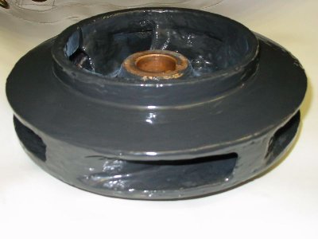

TR200 Ceramic Carbide Compound

TR205 Abrasion Resistant Ceramic Fluid

TR210 Low Friction Coating

TR220 High Temperature Ceramic Compound

TR230 Flexible Ceramic Carbide Paste

TR235 Flexible Ceramic Carbide Fluid

TR240 Heavy Duty Ceramic Carbide Paste

CERAMIC CARBIDE REPAIR SYSTEMS- CHARACTERISTIC CHART

Product Code | Product Name | Pack Size | Mixing Ratio | Usable Life (20C) | Cure Time | GrindingTime | Coverage Rate per unit | Applied By | Max Temp Dry  - Continuous  Max Temp Wet  - Continuous |  |  |  | Surface Prep  - Degreased  - Manual  - Blasted
TR200 | Ceramic Carbide Compound | 2 kg | 3:1 | 25 mins | 60 mins | 2 hours | N/A | Spatula | 200 | 120 | 120 | 70 | * |  | *
TR205 | Abrasion Resistant Ceramic Carbide Fluid | 1 kg | 3:1 | 25 mins | 3 hours | 6 hours | 1.6 sqm  at 250µ | Brush | 250 | 120 | 120 | 70 | * |  | *
TR210 | Super Low Friction Efficiency Coating | 1 kg | 3:1 | 45 mins | 6 hours | 8 hours | 2.7 sqm  at 250µ | Brush | 150 | 120 | 80 | 60 | * |  | *
TR220 | High Temp Ceramic Carbide Compound | 3 kg | 3:1 | 60 mins | 6 hours | 8 hours | 0.8sqm at 250µ | Spatula | 250 | 170 | 180 | 150 | * |  | *
TR225 | Ceramic Carbide 88 | 3 kg | 3:1 | 30 mins | 1 hour | 6 hours | 3.7 sqm  at 125µ | Spray | 120 | 100 | 100 | 60 | * |  | *
TR230 | Flexiblised Ceramic Carbide Compound | 3 kg | 3:1 | 20 mins | 2 hours | 3 hours | N/A | Spatula | 150 | 80 | 80 | 50 | * |  | *
TR235 | Flexiblised Ceramic Carbide Fluid | 3 kg | 3:1 | 20 mins | 2 hours | 3 hours | N/A | Brush | 150 | 80 | 80 | 50 | * |  | *
TR240 | Heavy Duty Ceramic Carbide Compound | 5 kg | 3:1 | 60 mins | 3 hours | 8 hours | N/A | Spatula | 200 | 120 | 120 | 70 | * |  | *

Max Temp Dry – maximum temperature when in contact with dry products ie – powders

Max Temp Wet – maximum temperature when in contact with wet products ie – water, sewage, chemicals

CERAMIC CARBIDE REPAIR SYSTEMS

Use the table below to choose the right product for the application, then look at the following page for general characteristics on the product chosen. NOTE the table below is only a guide, if in doubt please contact our technical department for confirmation of the choice made.

Product Name | Cavitation Attack - Rebuild | Cavitation Attack - Coating | Chutes – Damaged (Liquids and Fine Powders) | Chutes – Damaged (Solids – high impact abrasion resistance) | Hopper - Worn | High Temperature Resistance 250C | Pipework – Liquids and fine powders | Propeller - Rebuild | Propeller - Coating | Pump Impeller -Rebuild | Pump Impeller -Coating - Water | Pump Impeller -Coating – Low Viscosity Liquids | Pump Impeller -Coating - Abrasive to High Viscosity Product | Sprayable Coating | Vollute - Rebuild | Vollute Coating -Water | Vollute Coating – Low Viscosity Liquids | Vollute Coating – Abrasive to High Viscosity Product | Vollute -Rebuild & Coating – High impact/ abrasion resist | Valve Rebuild | Valve Coating - Water | Valve Coating – Low Viscosity Liquid | Valve Coating – Abrasive toHigh Viscosity Product | Valve Rebuild & Coating – high impact/ abrasion resistance
TR200 Ceramic Carbide Wearing Compound |  |  | * |  | * |  | * | * |  | * |  |  |  |  | * |  |  |  |  | *
TR205 Abrasion Resistant Ceramic Carbide |  |  | * |  | * |  | * |  | * |  | * | * | * |  |  |  | * | * |  |  | * | * | *
TR210 Super Low Friction Coating |  |  |  |  |  |  |  |  |  |  | * | * |  |  |  | * | * |  |  |  | * | *
TR220 Ceramic Carbide 88 |  |  |  |  |  |  |  |  |  |  |  |  |  | *
TR225 High Temp Ceramic Carbide |  |  |  |  |  | *
TR230 Flexible Ceramic Carbide Paste | *
TR235 Flexible Ceramic Carbide Fluid |  | *
TR240 Heavy Duty Ceramic Carbide |  |  |  | * |  |  |  |  |  |  |  |  |  |  |  |  |  |  | * |  |  |  |  | *

WORN VALVES SEATS

The following ThistleBond section is concerned with the repair of corroded tubular heat exchangers and should be read in conjunction with the Technical Data sheets of the following ThistleBond Products: Ceramic Carbide Wearing Compound

COMMON DEFECTS
Worn valve seats are caused by excessive wear, Erosion and Corrosion from environment and chemicals.

PREPARATION
All work should be carried out in strict accordance with the relevant ThistleBond Technical Data Sheet. The product selection and application techniques should be based on the nature of the repair.

SURFACE PREPARATION
Surfaces should be thoroughly degreased with ThistleBond Universal Cleaner. The valve seat should be thoroughly prepared by abrading or grinding. Surfaces should once again be degreased. The valve itself should be coated with ThistleBond Release Agent.

APPLICATION TECHNIQUE
Ceramic Carbide Wearing Compound should be mixed as detailed in the product technical data sheet. The mixed product should now be spread onto the prepared surface using a spatula. The valve should now be closed using sufficient pressure to squeeze out excess product. The excess product should be carefully removed taking care not to disturb the valve. Once the product has cured as detailed in the technical data sheet, the valve can be opened or removed and the cured product dressed to remove any residual excess material. The valve can now be reassembled and returned to service.

TECHNICAL SUMMARY

PRODUCT ABRASION WORKING FULL CURE
RESISTANCE LIFE (20°C) (20°C)

CERAMIC CARBIDE

WEARING COMPOUND GOOD 20 MINUTES 2 HOURS

REBUILD OF ERODED AND CORRODED PUMP HOUSINGS

The following ThistleBond section is concerned with the rebuilding of eroded and corroded pump housings and should be read in conjunction with the Technical Data sheets of the following ThistleBond Products: Super Metal Rebuilding System, Extended Life Super Metal Rebuilding System, Rapid Setting Super Metal, PlasSteel Twist Stick, Ceramic Carbide Wearing Compound.

COMMON DEFECTS

Pitting and scarring on external surfaces produced by prolonged periods of exposure to highly abrasive products, leading to a reduction in performance and efficiency and ultimately holes in the outer surface of the pump housing. Without preventative maintenance or repair this can lead to scrapping of components.

PREPARATION
All work should be carried out in strict accordance with the relevant ThistleBond Technical Data Sheet. The product selection and application techniques should be based on the nature of the repair and the product being pumped.

SURFACE PREPARATION
There two types of repair that can be carried out by the ThistleBond product range.
- If the pump housing cannot be taken out of service, but the system pressure can be turned off for 1-4 hours, thus stopping any product passing through the pump. The outer surface of the pump housing should be abraded using a grinding disc to remove any surface rust or surface contaminants. The area to be repaired should then be cleaned using ThistleBond Universal Cleaners.

- If the pump can be taken out of service, then blast clean the damaged area to Swedish Std SA 2 1/2 ensuring a profile of 75 microns minimum using an angular grit. This method of surface preparation will ensure a longer lasting repair. After blasting, all damaged areas must be cleaned using ThistleBond Universal Cleaners.

APPLICATION TECHNIQUE
In situ repair and out of service repair– Using the chosen ThistleBond product, apply the material, using the applicator provided, in to the hole or crack. Ensure that the product applied has been pushed sufficiently into the surface of the pump housing and covers al of the effected area. Once this has been achieved apply the ThistleBond material onto the surrounding area to the repair, approximately 2” in all directions. The product should then be left undisturbed to fully cure before the equipment is returned to service.

TECHNICAL SUMMARY

PRODUCT ABRASION WORKING FULL CURE
RESISTANCE LIFE (20°C) (20°C)

SUPER METAL

REBUILDING SYSTEM GOOD 20 MINUTES 72 HOURS

RAPID SETTING SUPER METAL GOOD 2-3 MINUTES 2 HOURS

PLASSTEEL TWIST STICK FAIR 2-3 MINUTES 2 HOURS

CERAMIC CARBIDE

WEARING COMPOUND EXCELLENT 25 MINUTES 24 HOURS

ERODED GATE VALVES

The following ThistleBond section is concerned with the repair of corroded tubular heat exchangers and should be read in conjunction with the Technical Data sheets of the following ThistleBond Products: Ceramic Carbide Wearing Compound

COMMON DEFECTS
Eroded gate valves are caused by excessive wear, erosion and corrosion from environment and chemicals.

PREPARATION
All work should be carried out in strict accordance with the relevant ThistleBond Technical Data Sheet. The product selection and application techniques should be based on the nature of the repair.

SURFACE PREPARATION
All corrosion products and degraded metal should be removed by grinding and needle gun, taking care not to damage the brass sealing ring. Surfaces should now be sweated to remove any ingrained corrosion products and salts. Further grinding should then be carried out to ensure a coarse surfaces profile. The prepared area should now be degreased with ThistleBond Universal Cleaner.

APPLICATION TECHNIQUE
Ceramic Carbide Wearing Compound should be mixed as required, according to the technical data sheet. The mixed product can now be applied to the prepared surface using a spatula. A thin coat should be first spread thinly over the surface to avoid air entrapment, especially in areas of deep pitting. The areas can now be filled with Ceramic Carbide Wearing Compound ensuring no air entrapment and smoothed off just proud of the sealing rings. Once the product is cured sufficiently for grinding, the repaired area can be dressed back to the correct dimensions using an electric sander.

TECHNICAL SUMMARY

PRODUCT ABRASION WORKING FULL CURE
RESISTANCE LIFE (20°C) (20°C)

CERAMIC CARBIDE

WEARING COMPOUND GOOD 20 MINUTES 72 HOURS

REPAIR OF CORROSION TO TUBULAR HEAT EXCHANGERS –
END PLATES

The following ThistleBond section is concerned with the repair of corroded tubular heat exchangers and should be read in conjunction with the Technical Data sheets of the following ThistleBond Products: Ceramic Carbide Wearing Compound and Abrasion Resistant Ceramic Carbide Fluid.

COMMON DEFECTS
Subject to heavy corrosion, due to the tubes being copper and the tube plates are of a different metal, being dissimilar metals in contact causes galvanic corrosion. The whole corrosion process is accelerated by the heat and wet conditions inside the equipment. If left unattended the corrosion process could completely destroy the tube plate.

PREPARATION
All work should be carried out in strict accordance with the relevant ThistleBond Technical Data Sheet. The product selection and application techniques should be based on the nature of the repair.

SURFACE PREPARATION
New Units: Prepare both ends and all components of the unit before applying the product. Remove the end plates and baffle. Stoppers should be inserted into each tube so that the stopper stands proud of the tube equal to the thickness of the product being applied. The stoppers should be all be at a current uniform level. The surface of the end plate should be abrasive blasted, after blasting blow all debris off the surface with clean oil free air. Degrease the entire surface of the plates with ThistleBond Universal Cleaners.

Worn Units: Remove the end plates and baffle. Blow out the standing water in the tubes with air, until they are dry. Degraded metal should be removed from around the tubes using a proper size tube saw, to cut a groove around each end of each tube. The degraded metal can now be chiseled from between each tube, take care not to damage the tube ends. Insert a rubber stopper into the end of each tube as before, taking the most protruding tube as the guide level to which all the stoppers should be pressed in. Once the stoppers have been inserted the surface is abrasive blasted. The blast surface must then be sweated using a blow torch to remove any ingrained salts, reblast if any are present. After thorough blasting, blow all the debris off the surface with clean air. Degrease the surface of the end plate using ThistleBond Universal Degreaser.

APPLICATION TECHNIQUE

Mix the appropriate quantity of product to fill any eroded/ pitted areas in the old tube plates. As soon as the product is set it can be over coated with the finish material. Mix the 1kg unit of Abrasion Resistant Ceramic Carbide Fluid, two coats of this product should be applied. Apply the first coat evenly over the prepared area, it is important to press or force the product around each stopper to force out entrapped air. As soon as the first coat is set apply the second coat and fill to the top of the stoppers. Smooth level with the top of the stoppers. After 24 hours the stoppers can be removed using a ball peer hammer, gently tap each stopper to break the bond between the cured product and the stopper.

TECHNICAL SUMMARY

PRODUCT ABRASION WORKING FULL CURE
RESISTANCE LIFE (20°C) (20°C)

CERAMIC CARBIDE

WERAING COMPOUND EXCELLENT 35 MINUTES 7 DAYS

ABRASION RESISTANT

CERAMIC CARBIDE FLUID EXCELLENT 40 MINUTES 7 DAYS

PUMP EFFICIENCY AND ENERGY CONSUMPTION

World Industrial Electrical Energy Demand
25 % Pumping Systems
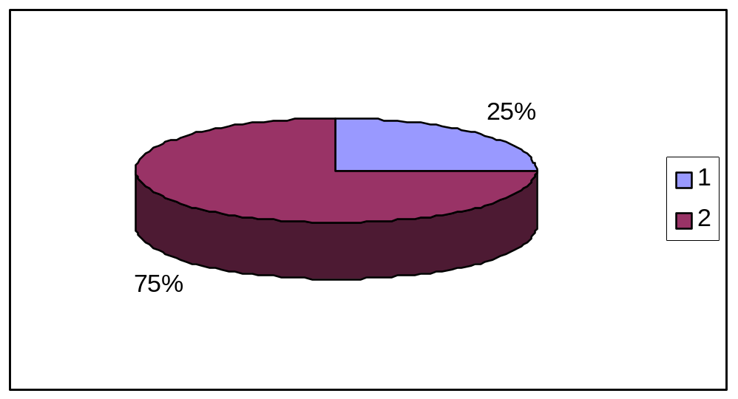
Industrial Plant Energy Usage
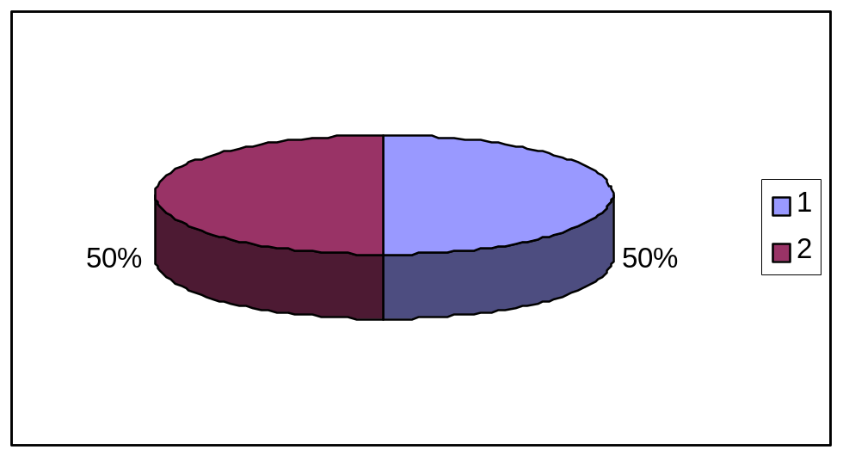Pumping Systems 25-50%

Pumping systems account for nearly 25% of the world’s industrial electrical energy demand and range from 25%-50% of the energy usage in certain industrial operations. Pumping systems are used in everyday life life from, domestic appliances to the water we drink from the tap.

Life Cycle cost of an Industrial Pump
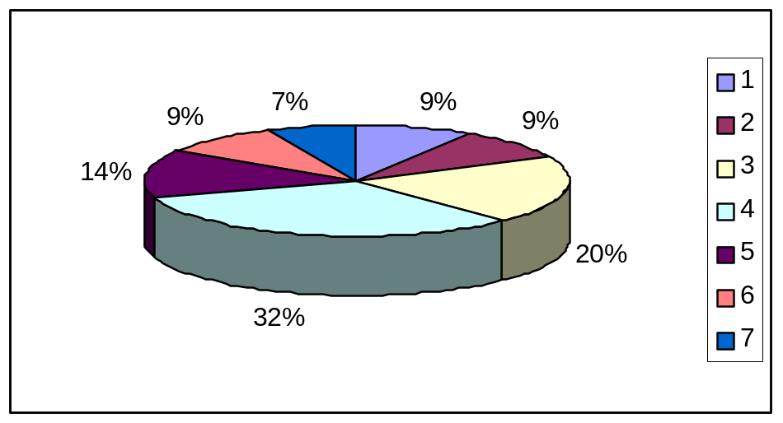
32% - Energy cost throughout working life
20% - Cost of maintenance
14% - Actual cost of pump when purchased
9% - Installation
9% - Downtime
9% - Operation costs
7% - Environment

As we can read from the graph above, the actual cost of the pump accounts for only 14% of the overall operating cost through the life of the pump. Energy and maintenance account for over 50%, with downtime adding another 9%.

Although in many cases it is not practical to change pumps and adjust operating efficiencies, there are ways of improving –

a). The flow rate in the pump
b). The Energy consumption
c). The cost of Maintenance.

ThistleBond has developed a low friction coating that is proven to

a). INCREASE the flowrate through the pump
b). REDUCE the Energy consumption
c). REDUCE the cost of Maintenance

The Super Low Friction Efficiency coating is a high performance solvent free coatings designed for use as a resurfacing and lining system to improve the efficiency in fluid flow environments.

Best Efficiency Point

All pumps when first installed are designed to work at their Best Efficiency Point, however there can be many reasons for the pump not to be operating at its B.E.P.

- Discharge Valve is throttled back
- Pump is started with closed discharge valve
- Closed valve on the system
- Suction pipework is corroded
- Damage by cavitation, abrasion and chemical attack to the wet end of the pump.

The ThistleBond TR210 Super Low Friction Efficiency Coating can help in the latter areas!

By rebuilding the damaged areas such as the Volute, Impeller, Back Plate, Flanges, Pump Casing etc, with the ThistleBond TR200 Ceramic Carbide Wearing Compound, we have extended the life of the component and equipment. However, to increase the efficiency and reduce the maintenance of the pump, a smooth and hard wearing surface must be applied to the repaired area.

The TR210 Super Low Friction Efficiency Coating is brush applied and has self leveling properties which enable the user to have a smooth finish to the repair.

General Ceramic Coatings Super Low Friction Efficiency Coating

As we can see from the two diagrams above, normal Ceramic Carbide Coatings leave brush marks across the surface, these offer areas of resistance when the fluid is pumped over the surface. However the self leveling properties of the ThistleBond TR210 Super Low Friction Efficiency coating means the majority of the brush marks are smoothed away, allowing the fluid being pumped to run more easily over the surface, Reducing Friction, Wear and Energy Consumption, while Increasing the Flow Rate of the pump.

Furthermore, the high concentration of Ceramic and Carbide particles within the coating offers a higher level of protection to the Metal component and equipment being repaired.

Over the TOTAL LIFE CYCLE OF THE PUMP, the majority of operating costs will be caused by:

A). Energy Consumption 32%
B). Maintenance 20%
C). Downtime 9%

TOTAL 61%

By using TR210 Super Low Friction Efficiency Coating, we can work to reduce all three of the above.

FOR EXAMPLE:

Cost of Pump £14,000

Energy Consumption £32,000
Maintenance £20,000
Operating £ 9,000
Downtime £ 9,000
Installation £ 9,000
Environment £ 7,000

TOTAL LIFE CYCLE COST OF PUMP £100,000

ThistleBond TR210 Super Low Friction Efficiency Coating is proven to increase flow rates by up to 10%, thus reducing energy consumption, maintenance and downtime.

Examples of Application

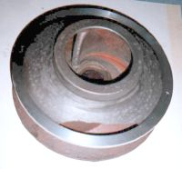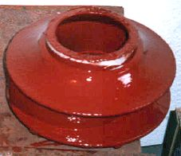

Before and After Impeller was coated with TR210 Super Low Friction Efficiency Coating (Red).

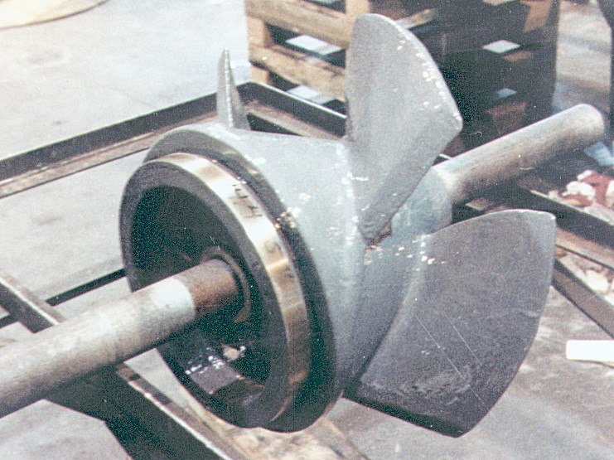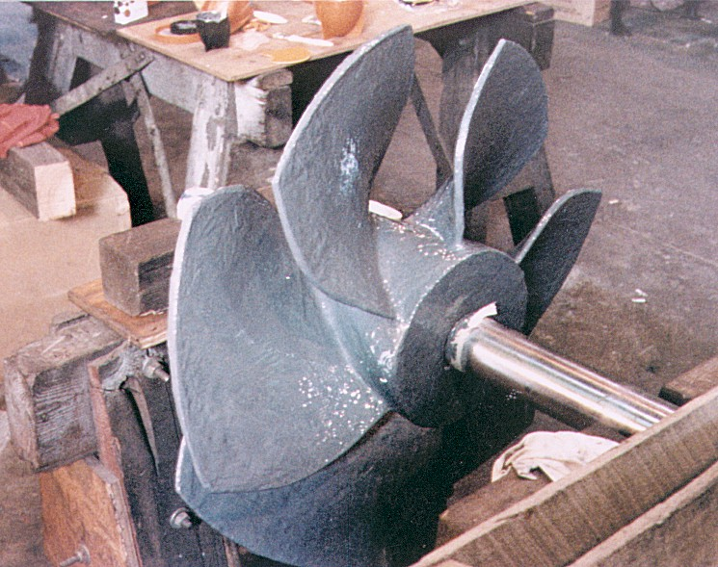

Pump Impeller blasted and cleaned with ThistleBond Universal Cleaner and coated with TR210 Super Low Friction Efficiency Coating (Grey)

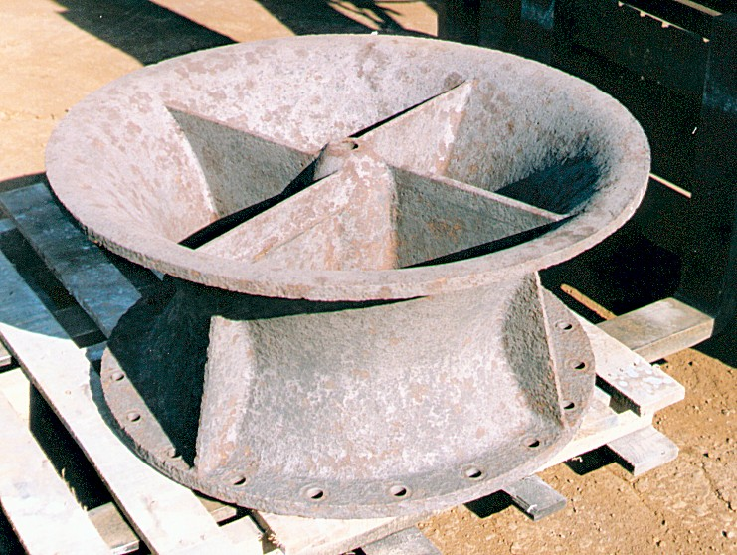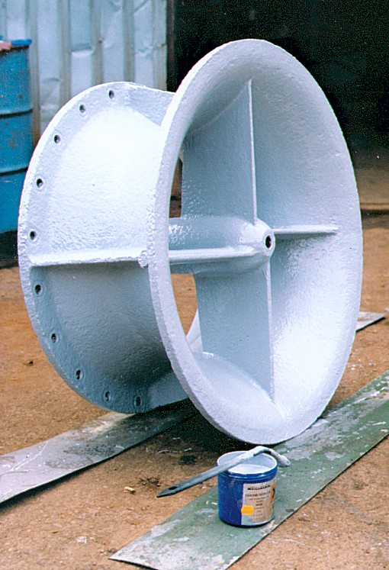

Pump Impeller blast prepared and coated with TR210 Super Low Friction Efficiency Coating

The ThistleBond Product Range from Start to Finish

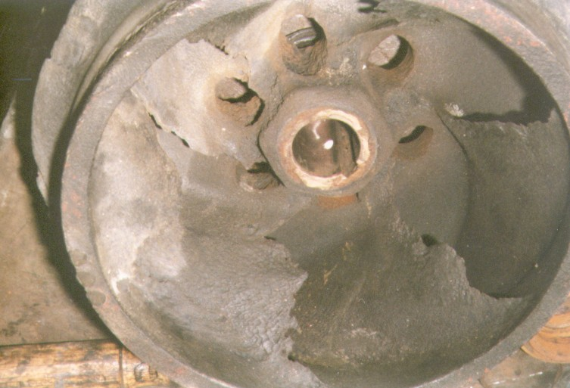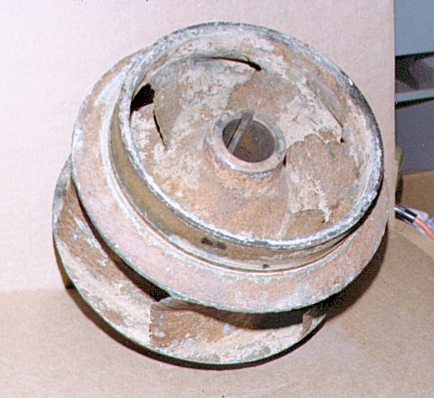

Pump Impeller ready to be blasted

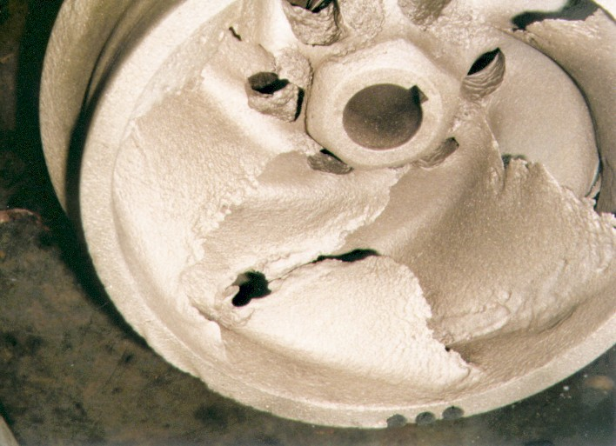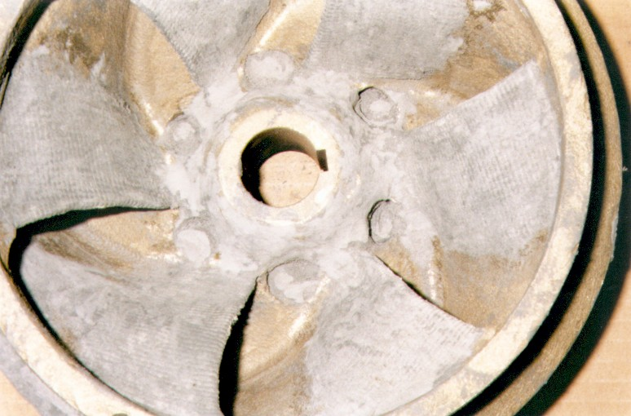

Pump Impeller blasted and then degreased with ThistleBond Universal Cleaner. The damaged blades rebuilt with TR200 Ceramic Carbide Wearing Compound

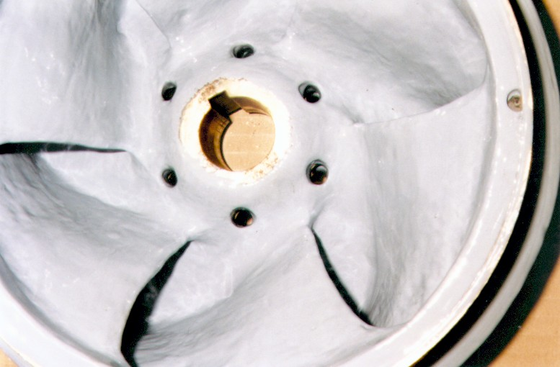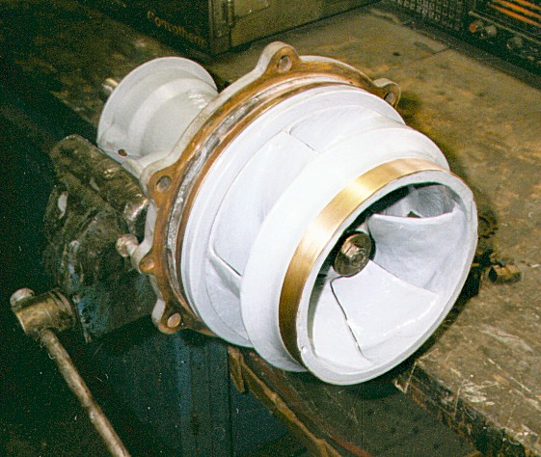

The Impeller is coated with TR210 Super Low Friction Efficiency Coating and left to cure
THISTLEBOND FAIRING COMPOUND AND ABRASION RESISTANT CERAMIC CARBIDE FLUID - ENGINEERING REPAIR AND MAINTENANCE

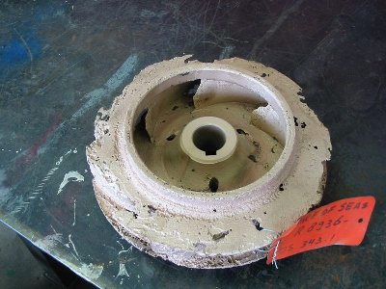
The Pump had been used on a Cargo tanker and been in operation for over 15 years. The performance and efficiency of the pump had become so bad that it was decided to take the equipment out of service and repair any damage. Unfortunately the spare part was no longer being manufactured by the OEM and so the shipping company looked to ThistleBond to repair the damaged components.

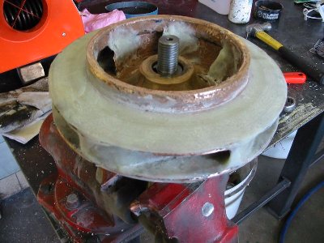
Wire was welded to the outer edges of the impeller, so as to obtain the original shape and dimensions. ThistleBond Standard Resin and Hardener was then mixed with Fairing Compound, a special blend of glass strands and flakes. The mixed product was applied by thin layers to the damaged component and eventually the impeller was brought back to its original shape.

Once the ThistleBond Standard Resin and Hardener and Fairing Compound had reached its minimum over coating time. Two coats of ThistleBond Abrasion Resistant Ceramic Carbide Fluid were brushed onto all the areas of the impeller. The applied product was then allowed to cure fully, before the impeller was put back into operation.

Water Pump Repair and Refurbishment

Netherlands

The ThistleBond Dutch Distributor was awarded the contract to repair and Refurbish one of the largest water pumps in the Netherlands. The entire piece of equipment was lifted from its existing station and transported to Roodhart’s Head office in Rotterdam. The pump was dismantled to assess the damaged to the wet end of the pump and to the drive shaft and components.

Once the assessment was finished, Roodhart came to ThistleBond to ask for a system recommendation for the products that would ultimately improve the efficiency and performance of the pump.
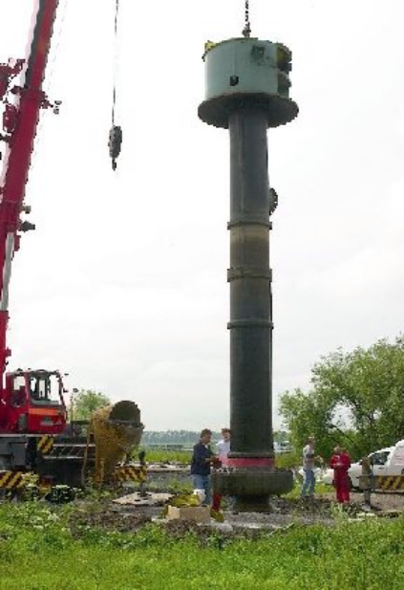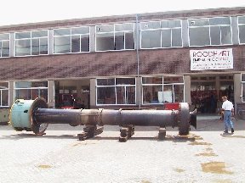

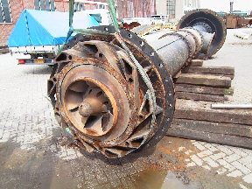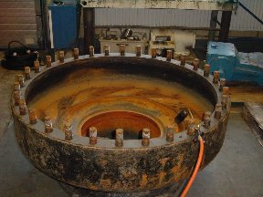

The wet end of the pump had been severely eroded over a period of years, the Impeller and Vollute were blast cleaned to industry standard Sa2½. All surfaces were then cleaned using ThistleBond Universal Cleaner. A check on the severely effected areas showed heavy pitting and scarring on large areas of the Vollute.
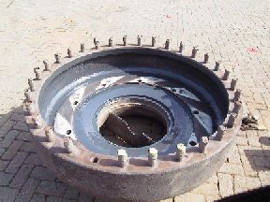
The pitting and scarring was filled using ThistleBond Ceramic Carbide Wearing Compound. Once this product had reached its minimum overcoating time, two coats of ThistleBond Super Low Friction Efficiency coating was applied to all of the surface areas of the Vollute and Impeller.

ThistleBond Super Low Friction Efficiency Coating has been approved by the WRAS for contact with Potable Water. The coating has been shown in tests to increase the flow rate and efficiency of the pump and thus reduce the energy consumption of the equipment.

